**DIGITAL MULTIMEDIA**

**PROJECT REPORT**



Love Hidden in the Leaves

|  |  |
| --- | --- |
| **PROJECT TEAM** | |
| **Student No** | **Student Name** |
| **X17347773** | **Tijesu Olalekan** |
| **X17342373** | **Abraham Marcus Alabi** |
| **X17366481** | **Christopher Angbalu** |
| **X17515503** | **Anthony Dempsey** |

Content

Contents

2. RESEARCH 2

3. SCRIPT 3

4. STORYBOARD 5

1. Overview

Our Project idea is online animation video that resolves around a love triangle between two best friends over a woman. The video will focus around the

# MARKET RESEARCH

In this report, I will be reviewing other animation shows that other development companies have produced.

The first animation production that we looked at was Problem Solvers. The Problem Solvers is an American animated television series that aired on Cartoon Network. Created by Ben Jones, it follows Alfe, Horace, and Roba, a group of detectives in their troubled town, Farboro. There is a triangle between these three characters and they’re journeys revolve around each other.

This animation style of this production was very colourful and in your face. This animation has many pros and cons. Some pros this animation has the colour and the very original backdrops. Some cons to this animation is that the eyes on the people are very big and the people and creatures are very unrealistic. For our production we want a more realistic animation that looks more like real life.

We didn’t like this production and we all agreed this is not what we want ours to look like. This production is the opposite of ours and we don’t want our production to look like this at all.

The second animation production we looked at was Avatar: The Last Airbender. Avatar: The Last Airbender is an American animated television series that aired for three seasons on Nickelodeon. The Series follows Aang, Katara and Sokka. There is a triangle between these three characters and they’re journeys revolve around following Aang.

This animation production was very colourful and childish but the style was very realistic in the characters face which we liked very much. The pros and cons of this animation production, some pros for this animation was the faces of the characters were very good and realistic and the backdrops looked like real life. Some cons were there was too much colour in certain situations which too away from the realism.

We liked the animation of this production and we all agreed that the faces of the characters were what we wanted but the extra colour didn’t like and didn’t want it in our production.

The Third animation production we looked at was Archer. Archer is an American adult animated sitcom created by Adam Reed for the basic cable network FX. The Series follows Sterling Archer, Lana Kane, Cheryl Tunt. There is love triangle between these three characters.

The animation style of this production is very realistic and has real life colours and style to the characters. The pros and cons of this animation production, some pros for this animation was the characters have realistic faces and clothes and the colours used are very life like. The backdrops are real city’s which looks great. The cons of this animation is that there is a lack of backdrops and the animation is normally on the face of the character.We liked this animation and will try to use some of this animation in our production

From looking at these examples of animation productions I found that they all a triangle of characters in common and they all allowed the characters enough screen time. All of the productions have music and great backdrops or backgrounds.

## STORYBOARD

Story:

Love triangle between Elijah Nathaniel and clementine.

Clementine is in love with Elijah, but Nathaniel has been in love with clementine for time.

Elijah is Nathaniel best friend who soon kills Nathaniel in a heated argument which

Elijah raps the body up put in his 4by 4.

They hide the body in the forest, but clementine drops he pink glove at the burial site

A dog-walker his dog of the leash and the dog follows the scent of the blood from the body and the dog walker follows after finding the glove and the dog start digging to be continued…

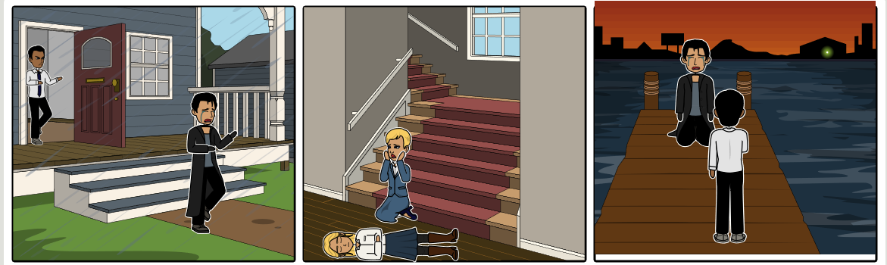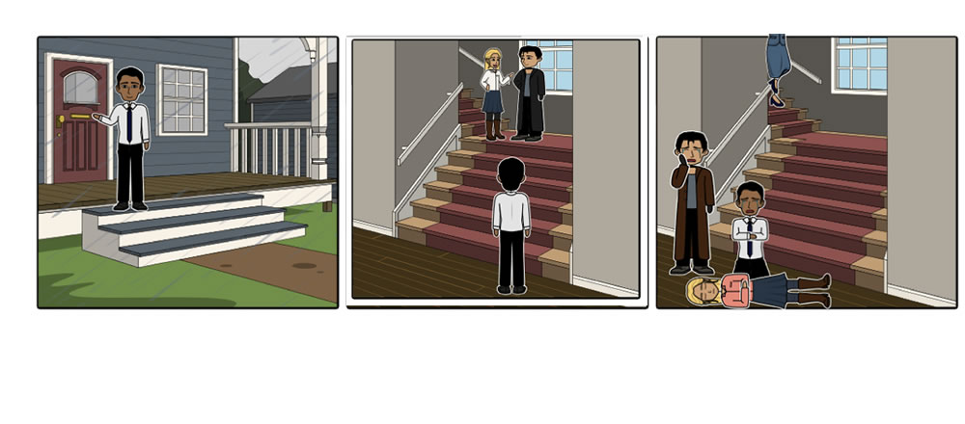

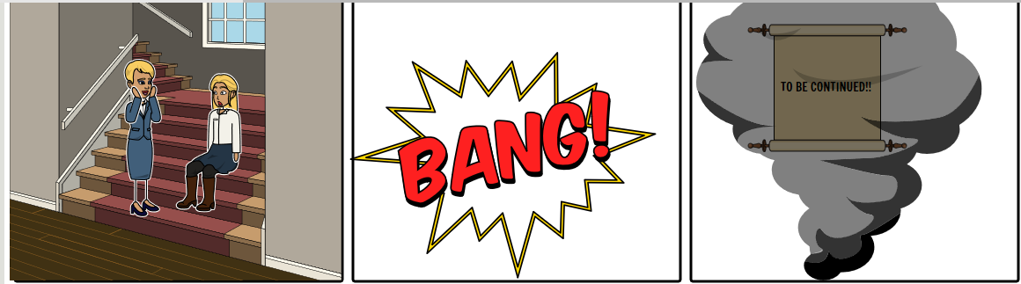

# SCRIPT

Scene 1:

* Rain is pouring down heavily, as if it feels like the nature knows what’s about to occur.
* Nathaniel is arriving at clementine’s house, only to notice that the door isn’t completely closed.
* Nathaniel decides to walk in.
* He glances over vaguely for clementine.
* He walks towards the staircase.

Scene 2:

* Clementine and Elijah are having discussion about a business proposition.
* Before Elijah leaves, at the top of the stairs, clementine and Elijah are seen to be kissing each other to state their goodbyes.
* Before Elijah could descend, Nathaniel is watching in shock at the bottom of the stairs.
* Nathaniel in shock, begins to shout asking for an explanation while walking up the stairs to confront Elijah.

Scene 3

* Elijah trying to explain to Nathaniel, that nothing happened & that it’s a misunderstanding.
* With no words reaching Nathaniel who is blinded with anger, rage & disappointment, he begins to attack Elijah.
* At this stage Elijah and Nathaniel are fighting, while clementine is shouting & trying to prevent Nathaniel from hurting Elijah.
* Elijah accidently throws Nathaniel towards Clementine, making Clementine trip up her own feet & thus falling down the stairs.
* Only after reaching the bottom did two men realise what has occurred & rush down the stairs to help her.
* Both men begin to cry. Still in shock, Nathaniel tries to wake her up with no result, crying and shouting her name, only for clementine’s maid to notice the loud noise and rush down in investigate what has occurred.

Scene 4

* Stunned with the event that just occurred, Elijah sobbing, flees the scene.
* As he runs outside, the rain pour increased & small breeze began to flow.
* Nathaniel enraged, tells the maid to call 911. He looked for Elijah & notice Elijah is gone.
* He purses Elijah shouting his name with a vengeful desire.

Scene 5:

* The maid sits beside clementine, trying to wake her up. She calls the ambulance.

Scene 6:

* After driving and running, Elijah stops at the sea dock, looking out into the sea.
* Nathaniel appears from behind.
* He tells Elijah that he killed clementine because she loved Nathaniel instead of Elijah.
* Elijah tries to explain to Nathaniel, it was an accident.
* He drops to his knees, crying & telling him it was an accident.
* Nathaniel with anguish, Nathaniel brings out a loaded hand pistol.
* Elijah’s fear from seeing the hand pistol gets to him, his heartrate begins to increase rapidly.
* As it comes to the realization that his life depends on his best friend, who he calls brother.
* Nathaniel, filled with torment, blinded by his love for clementine, his hand begins to shake as he cocks the shooting pin.

Scene 7:

* Clementine awakes from a stasis with a sharp inhale.
* The maid is crying with happiness.

Scene 8:

* In the same moment of clementine’s revival, a gunshot goes off.
* The screen goes black.

Scene 9:

* Sound of rain is still pouring.
* The smoke of the gunshot appears
* In the smoke, words appears.
* TO BE CONTIUNED.

# PROJECT TEAM

This section will outline what each member of the group has contributed to the project and what roles where given to members of the team. Our team came in during our 3 times a week during our Easter break to brainstorm ideas and communicate with each other. Everyone in the group had an input into what topic we would do and everybody took ideas into consideration when deciding how we were going to implement the animation.

|  |  |
| --- | --- |
| Name | ROLES |
| Anthony | * Editing * Researcher |
| Christopher | * Editing * Agenda Writer |
| TJ | * Storyboard * Editing |
| Marcus | * Scriptwriting * Editing |